CHRISTIAN EDUCATION HOUR

Sunday School classes do not meet in the summer months. Classes will resume in September.

Call to Worship and Affirmation of Faith

Breath of Life (Genesis 2:7)
Could I live without you?
No more than I can exist
Without oxygen for my lungs.
You sustain my pulse of life
Both internally and externally.
Each breath of your love
Rejuvenates my spirit.
You sustain my daily rhythms
Of being a loving presence
In all I am and all I do.
-Joyce Rupp

Prayer
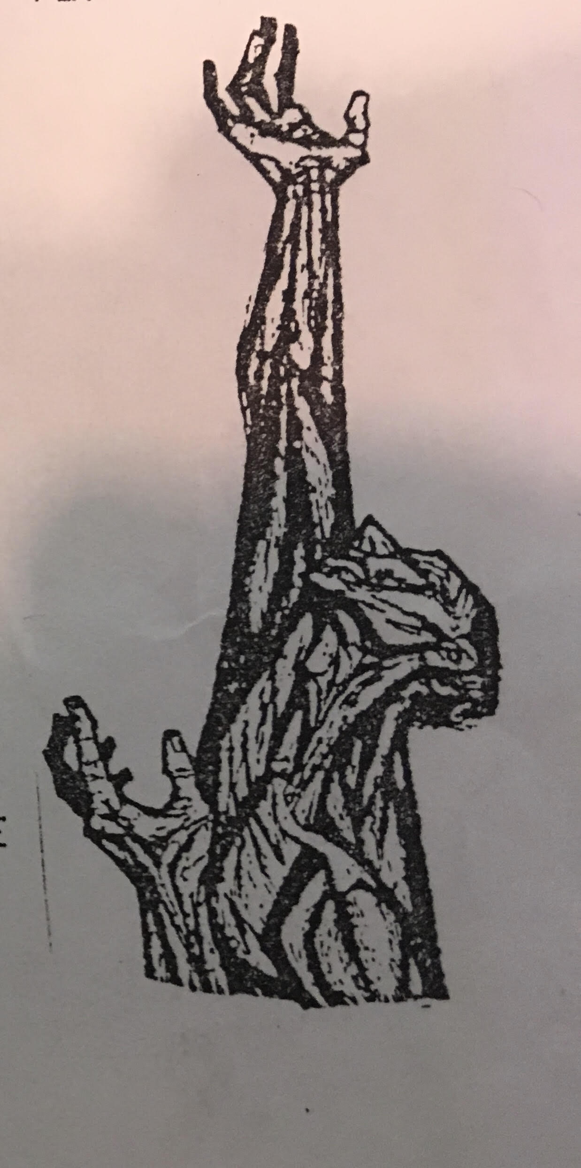
Now
Oh Lord.
Calm me into a quietness
That heals
and listens,
and molds my longing
and passions
my wounds
and wonderings
into a more holy
and human
shape.
- Ted Loder
GUERILLAS OF GRACE
PAOLI MENNONITE FELLOWSHIP
August 18, 2019
We welcome all persons
to worship, study and fellowship with us as we continually
seek to be faithful disciples of Jesus.

Focus: “The moment we claim the truth of being the Beloved, we are faced with the call to become who we are!”
Gathering to Worship
Song: Yonder come day
Welcome and Introductions
Call to Worship and Affirmation of Faith: (see back of bulletin)

Singing Our Praise
Everlasting Arms
Amazing Grace – H 143
Somebody touched me
Scripture: John 1:1-12

Celebrating Shalom – Kara Schmidt
Opportunities for Generosity: – Special giving for August goes to OCCF-Good Samaritan Fund
Hearing God’s Word
Children’s Time
Prayer from Guerillas of Grace (see back of bulletin)
Song: O God, we call
Stories of Experiencing the Divine: Mallery Hayre & Larry Moore and Milka Nunez
Responding
Sharing Joys and Concerns
Announcements
Closing Affirmation
ALL: "We live by the love that casts away fear,
And follow the Light of the World."
This Weeks Mantra: “I breathe in Divine Love.”

Please store all song books underneath the chair and clean off the tables before leaving. Thank you!

PASTOR-ELDER TEAM
Darren Bender-Beauregard, Pastor of Youth Formation 723-5259
Doris Weaver 723-2841
Deb Giles 865-5480
Stori Sullivan 865-0445
Phil Mininger 278-4741
Crystal Shellenberger 723-2035
TRANSITIONAL PASTOR: Tom Kauffman 419-343-4363
Email: tomk.transitionalpastor.pmf@gmail.com
SHORT TERM COORDINATORS: Evie & Wally Shellenberger H: 723-3925 C: 812-653-9703
Evie’s office hours: Tues. & Thur. 8am – 12 pm
SECRETARY: Deb Giles; office hours – Wed. and Fri. 9:00 am – 12 noon.
CHURCH OFFICE: Phone: 812-723-2414, email: mennos.paoli@gmail.com, Address: 2589 N C R 100 W. Paoli IN. 47454.

OUR COVENANT

In covenanting together, we affirm that Jesus Christ is Lord. We gratefully acknowledge him as our Lord and accept his teaching as the way to live. We recognize the importance of:
- Regular Bible study, worship with others, and prayer as a vital part of our Christian life.
- Taking each other seriously, contributing our gifts and caring for one another in love to strengthen the Christian body.
- Living and sharing the Good News as Christ has taught us and as the Holy Spirit enables.

TODAY Aug. 18, 2019 (worship at 9:30 am) |  |  |  |  |  | NEXT SUNDAY August 25, 2019,
 |  |  |  |  |  | Summer Campout – Worship at Tipsaw Lake
Worship Leader: |  |  |  |  | Mary Mininger |  | Worship Leader: |  |  |  |  | Tom Kauffman
Music Leader: |  |  |  | Dave Woodsmall |  |  | Music Leader:
Meditation: |  |  | Mallery Hayre & Larry Moore  Milka Nunez |  |  |  | Meditation:
Greeters: |  | Jon & Crystal Shellenberger |  |  |  |  | Greeters:
Nursery: |  | Beth Walden/Fisher & Espri Bender-Beauregard |  |  |  |  | Nursery:
A.V.: |  |  |  |  |  |  | A.V.:

today

NEXT SUNDAT
PMF's summer camp-out will be August 23-25 at Tipsaw. More information will be available later.
THIS WEEI
Thur. Aug 22, PET meeting, 7:00 p.m.
UP COMING
On Sunday, September 8, at 2 p.m. we will remember Rosie Allen by hanging her plaque on the Memorial Wall. Everyone is invited to be a part of that service.
On Sunday, September 8, we will begin a three-week Circle of Grace series for all our children and youth. These classes will take place following worship. The goal of the Circle of Grace program is to educate and empower children/youth to actively participate in a safe environment for themselves and others. Brochures about Circle of Grace are on the table in the foyer.

ANNOUNCEMENTS
Wally and Evie will be out of town from August 21 through September 4. For pastoral care needs contact Tom Kauffman. For coordination concerns talk to any member of PET.
The Children’s Education committee has begun planning for Sunday School this coming year. We are looking for teachers and helpers who are willing to help out in our classes. If you are available to help out for a quarter or several Sundays each month contact Shanna Johnson or Evie Shellenberger. Thank you for giving this important work consideration.
Amigo Centre is sponsoring an MCC Bike Michiana event September 13-15. Those interested will join other bicycle enthusiasts of all skill levels for an enjoyable experience of pedaling the beautiful lake and farmland region of southern Michigan and northern Indiana. Juan Pacheco, the Peace and Justice Coordinator will provide education on the work of MCC in relation to Immigration work in the Great Lakes region and at the Borderlands. More information is on the table in the foyer.

